Elite up Skill Sessions
These sessions are designed by former NZ national and Hockey Victoria High Performance coach Jesse Workman and International Athletes Matt L’Huillier for junior players aged between 10 and 19 who are hoping to improve their Hockey for the back half of the season or are wanting to make Zone, State or national teams within the next year or two.
Coaches Include International Athletes Matt L’Huillier (below right), Nicholas Dumont (below left) as well as Dutch defender Rens Vernij and Victorian Locals Edward Arnold and Josh Ephraums (Victorian U21 athletes).

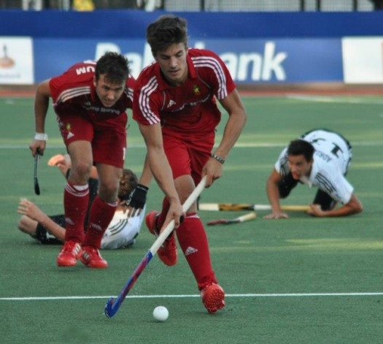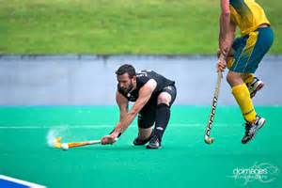

Just select from the following options: (please note that places are given on a first in, first served basis and there are only 6 places available per session)
What you will receive
- 1.5 hours of highly specialised coaching from some of the best coaches and Athletes around
- A written report detailing the sessions and giving areas for improvement as well as drills and exercises to keep improving the skill
- Video analysis and feedback
- Each athlete will receive a drink per session

Day 1 | Monday 6th July
9am | Goal Scoring
 | Drag Flicking
 | Defending the Dutch Way
 | Overheads and aerial skills
11am | Goal Keeping
 | Passing and Outletting skills
 | Decision making, vision and awareness
 | Reverse stick skills
1pm | Ball carrying and eliminations
 | Drag Flicking
 | Goal Keeping
 | Tackling, defending and marking
Elite Up Skill REGISTRATION FORM

Please complete your registration form and email it to: jesseandsherryworkman@gmail.com
Or send an email to register your interest

Name:

Age:

Address:

Phone:

Email:

Payment: $40 per session.
Jesse Workman
BSB: 063148
ACC: 10279703
Alternatively, contact Jesse to arrange payment another way, cash on the day is fine with prior arrangement.

Any questions or queries please don’t hesitate to contact Jesse or Matt at:
jesseandsherryworkman@gmail.com
Or
Jesse: 0449632857

We are only taking 6 players per session to avoid disappointment please get in early.

