HOCKEY HOLIDAY PROGRAM
With coaching from International Players Matt L’Huillier (below right) and Nicolas Dumont (below left) and lead by Junior NZ national and Hockey Victoria High performance coach Jesse Workman.
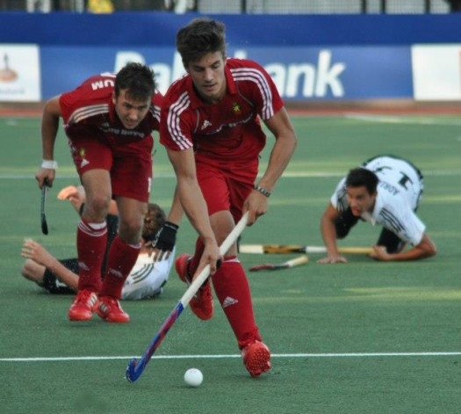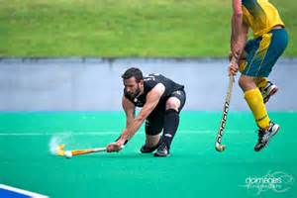

Come down and learn from the best to be the best. Other coaches include, Australian Futures athlete and Waverley Premiere League athlete Damon Steffens and Victoria U-21 athlete Josh Ephraums.
Be part of the Holiday Program.
We cater for all levels!

WHEN: June 29 and 30, 2015.
What will you receive?
- 12 hours of top quality coaching from some of the best players and coaches around, for less than $10 an hour.
- A player report card with 2 strengths and 2 areas of improvement
- A drink each, per day.
- The chance to win one of several prizes including brand new hockey sticks.

TIME: 9am – 3pm
WHERE: Kingston Heath Reserve,
74 Farm Road, Cheltenham
AGE: 7-15 year olds, all players will be
grouped by age and ability to ensure
everyone is learning at the same level.
COST: $80 for the 2 days

HOLIDAY PROGRAM REGISTRAION FORM

Please complete your registration form and email it to: jesseandsherryworkman@gmail.com

Name:

Age:

Address:

Phone:

Email:

Payment:
Jesse Workman
BSB: 063148
ACC: 10279703
Alternatively, contact Jesse to make payment another way. Cash on the day is acceptable with prior arrangement.

Any questions or queries please don’t hesitate to contact Jesse at:
jesseandsherryworkman@gmail.com
Or
Jesse: 0449632857

The program will include:
- Basic Technical skills
- Advanced Technical skills
- Tactical awareness
- Decision making
- Generic sport concepts
- Fun activities

